2.D.1. The ViNe Approach to Software-Defined IP Overlays

**2013 Highlights**

ViNe is a project developed at the University of Florida that implements routing and other communication mechanisms needed to establish wide-area IP (internet protocol) overlays. Not all PRAGMA resources (physical or virtual) can be configured with publicly accessible IP addresses, and ViNe can offer an overlay network solution to enable communication among resources on public and private networks without the need for reconfiguring the physical network infrastructure.

ViNe has two main components: the ViNe Infrastructure (consisting of ViNe routers or VRs, with a focus on the ability to re-establish connections if a disruption occurs as well as to establish means to traverse firewalls (i.e., connectivity recovery/tunnel establishment) and fast transport of overlay packets) and the ViNe Management (consisting of an overlay management system that is responsible for the operation and reconfiguration of VRs). Both components provide application programming interfaces (APIs) that enable self-management of virtual networks (e.g., ViNe Management invokes VR APIs to configure new overlay routes for the deployment of a newly defined virtual network). They also provide software defined IP overlays (e.g., changes in overlay topology can be initiated by end users, cloud middleware, and/or application software by invoking ViNe management APIs).

With instructions prepared by the UF team, the UC San Diego and IU teams were able to quickly deploy ViNe technology in their clusters managed by Rocks cluster software. An additional cluster, at AIST, was also “ViNe-enabled” to run initial experiments. VM live-migration and the HTCondor workload management system were selected as sample applications to run on ViNe overlays.

VM live-migration demonstrations illustrated the connectivity enabled by ViNe overlays by making it possible to (a) remotely access physical machines in private networks (AIST and UF); (b) establish file sharing (NFS) through ViNe overlays; and (c) move VMs between AIST and UF without stopping them.

HTCondor was set up using VMs hosted at UCSD, AIST, UF, and IU and connected through ViNe overlays. Demonstrations during PRAGMA-24 highlighted the “software definition” aspects of ViNe: (a) ViNe software was quickly deployed on a laptop in Thailand; (b) a VM running on the laptop was connected to the overlay and joined the Condor pool; (c) through a command-line interface, it was shown how quickly and easily a VM can move from one ViNe overlay to another isolated ViNe overlay; and (d) it was shown that it is possible to easily change the set of ViNe management commands/interfaces to support different overlay programming needs.

We are planning to expand ViNe deployment to reach more PRAGMA sites, and offer user-controlled isolated overlays for different applications.

Participants: UF: José Fortes, Maurício Tsugawa; IU: Yuan Luo; UCSD/SDSC: Phil Papadopoulos, Cindy Zheng, Nadya Williams, Luca Clementi; AIST: Yoshio Tanaka

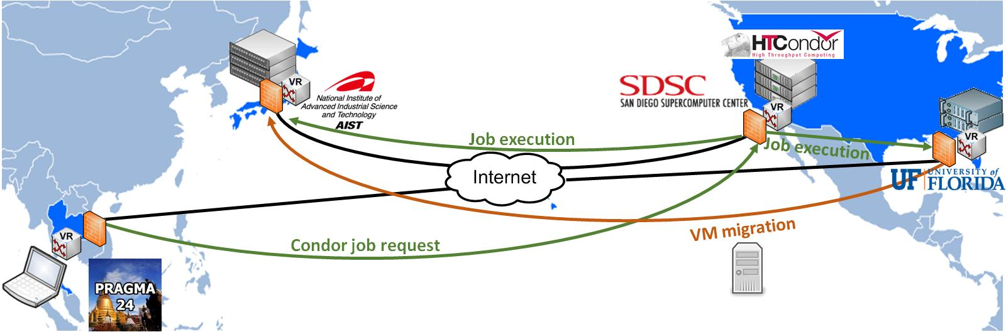

Figure : ViNe established the communication among physical and virtual resources on private networks at SDSC, UF, AIST, and PRAGMA-24 workshop site (Thailand). This setup allowed live wide-area VM migration experiments and the deployment of a Condor pool across multiple countries.